Instruction Manual for Micro Hematocrit Centrifuge DSC-100MH-2
Lid
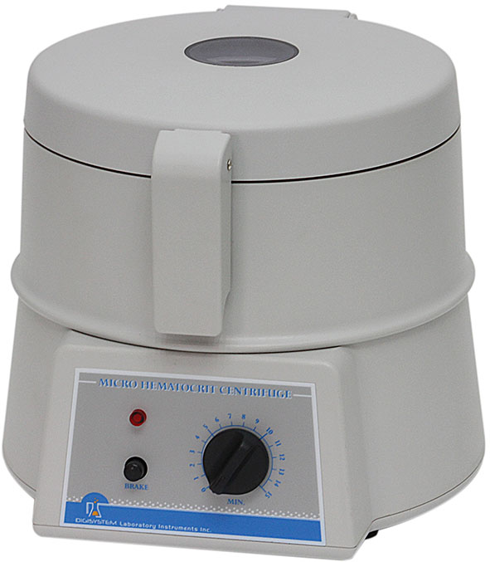

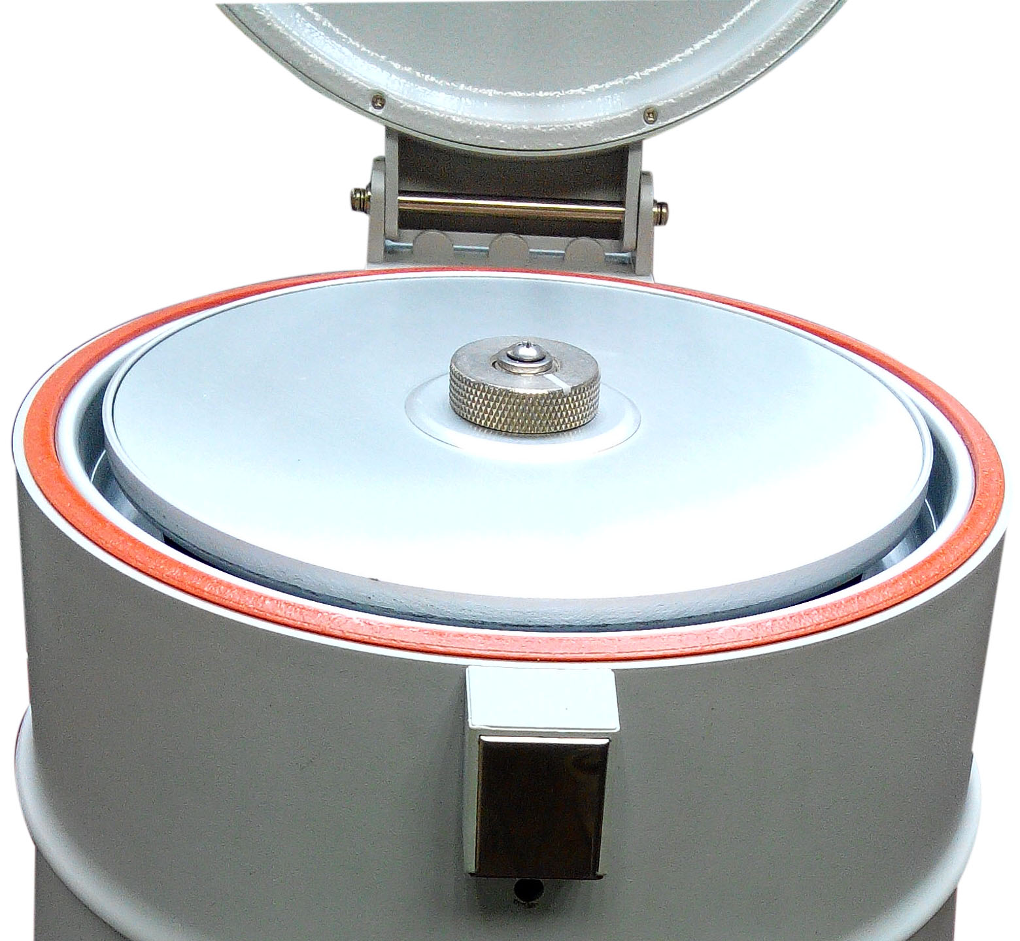
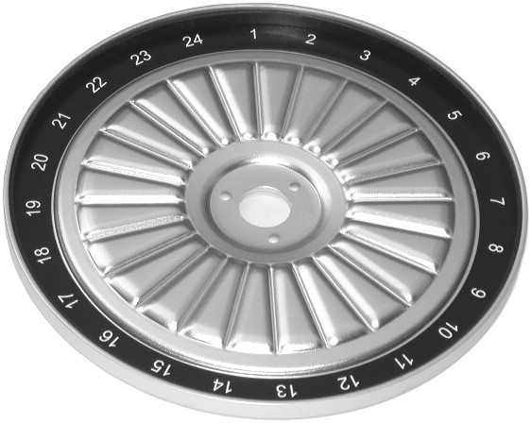

Power
Indicator

Timer

Manual brake button

Disc rotor

Disc rotor nut

Warnings:
* Do not open the lid before the centrifuge stops completely.
* Do not remove the centrifuge during operation.
* Do not put objects on the top of the lid.
* Do not disassemble the centrifuge by yourself. In the event of a malfunction, the centrifuge should be repaired by a qualified technician. Before repairing, turn off the power.

Steps:
- Place the centrifuge on a flat surface. Plug the centrifuge into a properly grounded outlet which corresponds with the electrical requirements on the label back on machine.
- Open the ‘Lid’, and then turn the ‘ Disc cover nut’ counter-clockwise to remove ‘Disc cover’.
- Set an even number of capillary tubes in a symmetrical position. Place the sealed end toward the outside, making sure that the tubes are seating in the grooves and firmly against the rubber cushion.
Caution: Before setting capillary tubes, please make sure that the rubber gasket exists and adjoins the edge of the “Disc rotor”. Without the rubber cushion, the capillary tubes will break during operation.
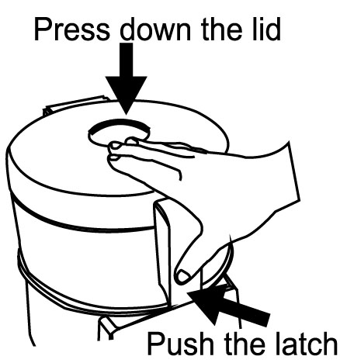
- Turn the ‘ Disc cover nut’ clockwise to screw down the ‘Disc cover’. And make sure it is screwed down. Then close the ‘Lid’. Please see the figure 1 to know how to close the lid.
Caution: Make sure that the ‘ Dick cover’ is screwed down, otherwise the capillary tube will break during operation.

Figure 1
- Turn the ‘Timer’ clockwise to set time. ( usually 3~5 minutes at 11,000 to 12,000 rpm). The ‘ Power indicator’ lights up.
Caution: In order to let the “Timer” work accurately, the “Timer” should be turned over the required value and then return back to the required value. For instance: if you need 3 minutes, you should turn the “Timer” to 5 or 6 minutes first, and then turn it back to 3 minutes.
- When the setting time reaches to the end, the bell signal “Don” will be heard.
- After the centrifuge stops completely, please open the lid and take out the capillary tubes and use the “Micro hematocrit reader” to measure the packed cell volume (PCV).
- By pressing “Manual brake button” is able to stop operation quickly. However, do not use stop action frequently unless it is in an emergent condition.
Caution: For long lasting life of the motor, do not press the ‘ Manual brake’ too tight in one time, it should be pressed and then released for more times.

Maintenance and care:
Keep the centrifuge clean all the time. Cleaning can be done with a damp cloth. Avoid the use of solvents as they may damage the product housing, rotor.
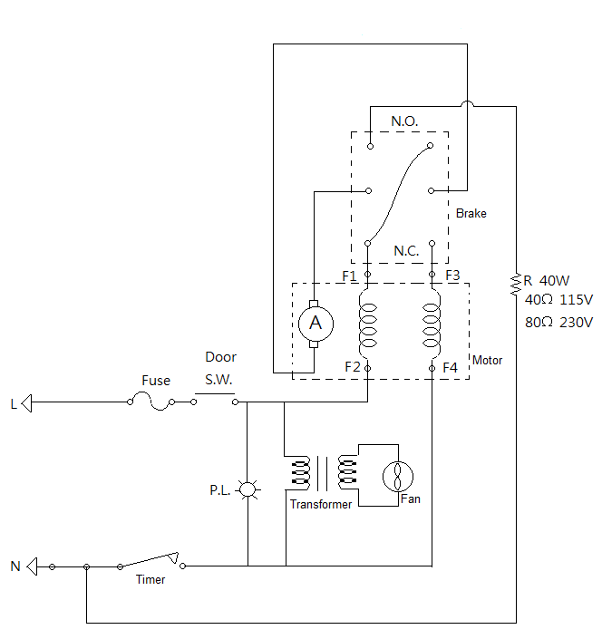
Circuit Diagram:

Using your micro hematocrit reader:
Acrylic stand
100% Line

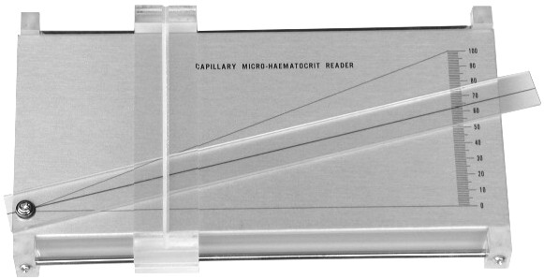
Meniscus
100%

Plasma
Acrylic reading bar
White cell
PCV

Read cell
0% Line
Colored band
0%
Wax
Micro hematocrit reader
Centrifuged capillary

Caution:
* Read the results immediately after the centrifuge stops.
* Do not place the tubes upright until they are read. The red cells will slide if the tubes are left in a horizontal position and the packed cell volume (PCV) will be falsely increased.

1. Place the centrifuged capillary tube in the groove of the “Acrylic stand”.
2. Let the interface of the wax and the red cell align with the “0% Line”.
3. Slide the “Acrylic stand” right or left until the “Meniscus” of the “Plasma” intersects the “100% line”.
4. Move the “Acrylic reading bar” until the top of the red cell column intersects the line on the “Acrylic reading bar”.
5. The reading that corresponds to the top of the red cell column is the packed cell value (PCV).

Service Manual

Troubleshooting Guide
Caution: Always disconnect the power cord before troubleshooting.
Trouble | Cause | Remedy
Motor is not working | Power code is not securely connected. | Reconnect it securely.
Motor is not working | Fuse is burnt. | Replace a fuse.
Motor is not working | Time switch is not set. | Turn the timer to a required scale.
Motor is not working | Lid is not closed well. | Open lid and close it again.
Motor is not working | The setting of micro switch is not proper or it is broken. | Contact the distributor for repair.
Motor is not working | Manual brake can’t release automatically. | Contact the distributor for repair.
Motor is not working | The contact of carbon and rotor is not well. | Contact the distributor for repair.
Motor is not working | The wiring of motor is not well. | Contact the distributor for repair.
Manual brake is not working | Manual brake can’t release automatically. | Contact the distributor for repair.
Manual brake is not working | Lid is not closed well. | Open lid and close it again.
Manual brake is not working | The resistance for manual brake is broken. | Contact the distributor for repair.
LED power indicator can not light up | The wiring of PC board and LED is not well. | Contact the distributor for repair.
LED power indicator can not light up | The LED is broken. | Contact the distributor for repair.
Motor can’t stop | The time switch is not at zero. | Turn it to zero.
The power is not cut off when open the lid | The setting of micro switch is not proper. | Contact the distributor for repair.
Capillary tubes break during operation | Rubber gasket doesn’t set well. | Set it again.
Capillary tubes break during operation | Rubber gasket is worn-out. | Replace a new one.
Capillary tubes break during operation | Disc cover doesn’t be screwed down. | Screw it again and make sure to screw it down.
Timer is not accurate | Timer is not set by the correct procedures. | Read the operation manual and set it again.
Timer is not accurate | Timer is broken. | Contact the distributor for repair.

